DATE: 2026-03-08

REVISION: C

TO: Geoffrey Butler, AE460 Instructor

FROM:

Aleborne

Luke Horton

Maxwell O’Neill

SUBJECT: V-n Diagram Analysis for AIAA Carrier-Based Strike Fighter

OBJECTIVE
This technical memorandum presents the V-n (flight loads) diagrams for the Next-Generation Carrier-Based Strike Fighter, developed in accordance with MIL-A-8861B and the Report Content Requirements (RCR) Section 5.1. The V-n diagrams define the structural flight envelope by plotting vertical load factor (n) versus equivalent airspeed (EAS) for four configurations: lightest and heaviest weight at sea level and at 45,000 ft cruise altitude.
The analysis uses updated aircraft parameters from the AE460 Master Sheet, with the maneuver envelope constructed from the stall boundary and MIL-A-8861B limit load factors, and the gust envelope computed using the Nicolai discrete gust method (Eq. 19.1) with the Pratt gust alleviation factor. A MATLAB implementation (Vn_Diagram.m) accompanies this memo for rapid recalculation as the design evolves.

Aircraft Layout
The current wing geometry used for this V-n analysis is taken from the WingLayout sheet of the AE460 Master Sheet. The key parameters are: wing planform area S = 457 ft², wing span b = 45 ft, aspect ratio AR = 4.431, taper ratio λ = 0.50, leading-edge sweep Λ_LE = 20°, and mean aerodynamic chord c̅ = 126.38 in (10.53 ft). Root chord is 162.5 in and tip chord is 81.2 in.
Note on Wing Area Discrepancy: The Maneuver sheet of the Master Sheet lists S = 600 ft², which is an outdated value from an earlier design iteration. The WingLayout sheet value of S = 457 ft² reflects the current, refined wing design and is used throughout this analysis. This discrepancy should be resolved in the Master Sheet by the wing sizing group.

Mass Properties
Two weight conditions are analyzed per RCR Section 5.1, which requires V-n diagrams at the lightest and heaviest weight configurations:
Heaviest Configuration — Strike TOGW (51,752 lb): This is the Strike mission takeoff gross weight from the Mission Weight sheet, consisting of empty weight W_e = 25,876 lb, full fuel W_f = 18,276 lb, and full Strike payload W_PL = 7,600 lb (4× MK-83 JDAM + 2× AIM-9X + avionics). Wing loading at this weight is W/S = 113.2 psf.
Lightest Configuration — A2A Landing Bring-Back (32,385 lb): Per RFP Section 3.2.2, the arrestment landing weight includes 25% maximum fuel and 50% stores weight. For the A2A mission: W_landing = W_e + 0.25×W_f + 0.50×W_PL = 24,808 + 4,827 + 2,750 = 32,385 lb. Wing loading at this weight is W/S = 70.9 psf.

Aerodynamics
The aerodynamic parameters used in this analysis are as follows. The maximum lift coefficient CL_max = 0.9 (clean configuration) is taken directly from the Maneuver sheet of the Master Sheet. The minimum lift coefficient CL_min = −0.9 is assumed based on a symmetric (or near-symmetric) airfoil, which is typical for fighter aircraft designed for maneuvering in both positive and negative g.
The wing lift-curve slope is estimated using the Nicolai incompressible low-aspect-ratio formula: CL_α = 2π·AR / (2 + √(AR² + 4)). With AR = 4.431, this yields CL_α = 4.058 per radian. This value is used in the gust load factor calculations. Note that compressibility corrections (Prandtl-Glauert) are not applied; at transonic cruise speeds these would increase CL_α and could slightly raise gust loads, but the aircraft is maneuver-critical so this does not change the governing design condition.

V-n Diagram Analysis

Design Speeds
The design cruise speed V_C is taken from the Wing_Area_Sizing sheet, corresponding to Mach 0.81 at sea level, yielding V_C = 903 ft/s EAS. The design dive speed V_D is set per MIL-A-8861B, which requires V_D ≥ 1.2×V_C. A factor of 1.25 is applied for margin, giving V_D = 1,129 ft/s EAS. These speeds should be confirmed with the performance group as the design matures.

Structural Limit Load Factors
Per MIL-A-8861B for fighter-category aircraft, the positive limit load factor is n_pos = +7.5g and the negative limit load factor is n_neg = −3.0g. The RFP Section 3.5 requires N_z > 7g at mid-mission weight, with 8.0g desirable; the +7.5g limit meets the mandatory requirement. The ultimate load factor is 1.5 times the limit (safety factor per MIL-A-8861B), giving +11.25g positive and −4.5g negative.

Maneuver Envelope
The maneuver envelope is bounded by four elements: (1) the positive stall boundary, a parabolic curve where n = ρ_SL · V_EAS² · S · CL_max / (2W); (2) the positive limit load factor line at n = +7.5g; (3) the negative stall boundary using CL_min = −0.9; and (4) the negative limit at n = −3.0g. The dive speed V_D closes the right-hand boundary.
Since all speeds are in EAS, the maneuver envelope is identical at all altitudes for a given weight. The key speeds are: for the lightest configuration (32,385 lb), V_S = 257 ft/s EAS and V_A = 705 ft/s EAS; for the heaviest configuration (51,752 lb), V_S = 325 ft/s EAS and V_A = 891 ft/s EAS. At the heaviest weight, V_A is very close to V_C, meaning the aircraft can pull maximum g near cruise speed — a desirable fighter characteristic.

Gust Envelope
Gust load factors are computed using the Nicolai discrete gust relationship (Ref. [1], Eq. 19.1): n = 1 ± (K_g · CL_α · U_de · V_e) / (498 · W/S), where K_g = 0.88μ/(5.3 + μ) is the Pratt gust alleviation factor, and μ = 2(W/S) / (ρ · c̅ · CL_α · g) is the mass ratio.
The derived gust velocities U_de from MIL-A-8861B (see Nicolai Fig. 19.2) are: at sea level, U_de = 50 ft/s at V_C and 25 ft/s at V_D; at 45,000 ft (linearly interpolated between the 20,000 ft and 50,000 ft values), U_de = 29.2 ft/s at V_C and 14.6 ft/s at V_D.
For the lightest weight at sea level (worst case for gusts), the gust alleviation factor K_g = 0.784 and the gust load increment at V_C is Δn = 2.41g, giving a maximum positive gust load of n = 3.41g. For the heaviest weight at sea level, Δn = 1.57g at V_C, giving n = 2.57g. At 45,000 ft, reduced gust velocities yield even smaller increments. In all cases, the gust loads remain well within the ±7.5g/−3.0g maneuver limits, confirming this aircraft is maneuver-critical.

Composite V-n Diagrams
Figure 1 presents the four V-n diagrams required by RCR Section 5.1. Each panel shows the maneuver envelope (solid boundary with shading) and the gust envelope (dashed lines). The top row shows sea-level conditions; the bottom row shows 45,000 ft. The left column is the lightest weight; the right column is the heaviest.
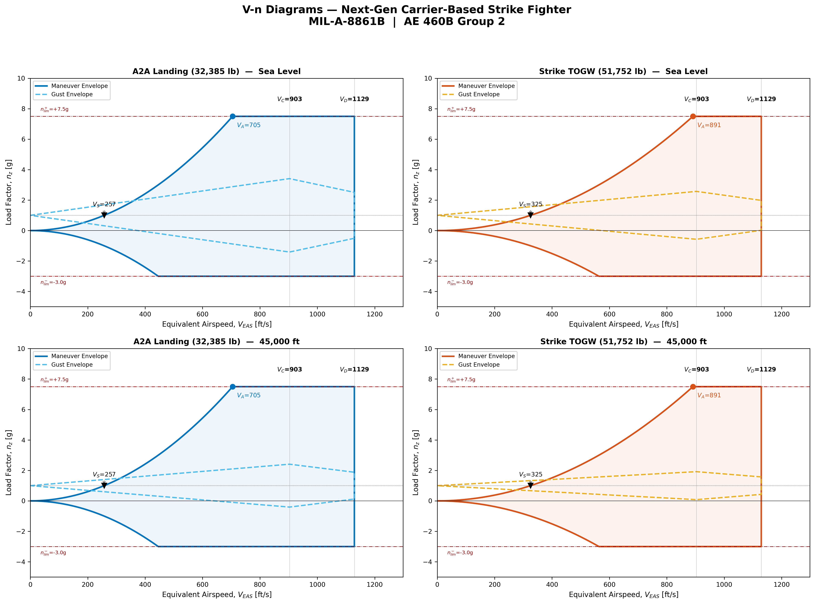
Figure 1. Composite V-n Diagrams (Maneuver + Gust) for Four Configurations

Assumptions
1. Wing Area: S = 457 ft² from the WingLayout sheet. The Maneuver sheet value of 600 ft² is outdated and was not used.
2. CL_min = −0.9 (symmetric airfoil assumption). If the wing uses a cambered section, CL_min may be closer to −0.6, widening the negative stall boundary.
3. Lift-curve slope: Estimated from the Nicolai incompressible low-AR formula. Compressibility corrections are not applied.
4. Design Speeds: V_C = 903 ft/s EAS (M=0.81 at SL); V_D = 1,129 ft/s EAS (1.25 × V_C). These should be confirmed with the performance group.
5. Gust velocities at 45,000 ft: Linearly interpolated between MIL-A-8861B values at 20,000 ft and 50,000 ft.
6. Lightest weight: A2A landing bring-back (W_e + 25% W_f + 50% W_PL = 32,385 lb) per RFP Sec 3.2.2.
7. Altitude: 45,000 ft used as highest cruise altitude, consistent with the Wing_Area_Sizing sheet.

Conclusions
The V-n diagram analysis establishes the structural flight envelope for the Next-Gen Carrier-Based Strike Fighter across the full range of operationally relevant weight and altitude conditions. The key conclusions are:
The aircraft is maneuver-critical, not gust-critical. Even at the lightest weight and sea level (the worst case for gust sensitivity), the maximum gust load factor at V_C is +3.41g, well below the +7.5g maneuver limit. This is a direct consequence of the relatively high wing loading (70.9–113.2 psf) characteristic of carrier-based fighters, consistent with Nicolai Ch. 19 guidance.
The 1g stall speed ranges from 257 ft/s EAS (lightest, landing configuration) to 325 ft/s EAS (heaviest, Strike TOGW), and the corner speed V_A ranges from 705 to 891 ft/s EAS. At the heaviest configuration, V_A = 891 ft/s EAS is close to V_C = 903 ft/s EAS, meaning the aircraft can pull full +7.5g maneuver loads at or near cruise speed — a desirable characteristic for a fighter designed for aggressive combat maneuvering.
The +7.5g positive limit meets the RFP requirement of N_z > 7g at mid-mission weight. The design team should evaluate whether increasing to +8.0g (the desirable target per RFP Section 3.5) is warranted given the resulting structural weight trade-off.

References
[1] Nicolai, L.M. and Carichner, G.E., Fundamentals of Aircraft and Airship Design, Volume 1, AIAA Education Series, 2010. Chapter 19: Structures and Materials.
[2] MIL-A-8861B, Airplane Strength and Rigidity: Flight Loads, U.S. Department of Defense.
[3] Roskam, J., Airplane Design, Part V: Component Weight Estimation.
[4] AE460 Master Sheet (AE460 MASTER SHEET.xlsx), Group 2 design data.
[5] AIAA RFP: Next Generation Carrier-Based Strike Fighter Aircraft, 2025–2026.

